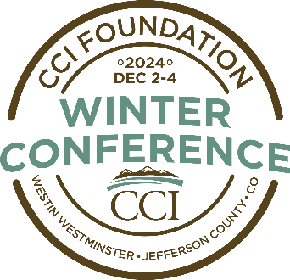

Tentative Schedule
All Meetings Held at the Westin Westminster
Schedule as of September 20, 2024

Monday, December 2

11:30am – 2pm ACCA Pre-Conference Workshop

Noon – 6 pm Registration Open

1:30 – 3pm CCI Concurrent Issue Session

1:30 – 3pm CCI Concurrent Issue Session

1:30 – 3m New Commissioner Session

2:45 - 3:15pm Coffee Break/Visit Sponsor Tables

3:15 – 4:30pm CCI Concurrent Issue Session

3:15 – 4:30pm CCI Concurrent Issue Session

4:30 – 6:30pm President’s Reception

Tuesday, December 3

7 am – 5pm Registration Open


7:00 – 8:45am Breakfast for All Attendees
Sponsored by CTSI

9 – 10:30am CCI Opening General Session

Speaker
Governor Jared Polis – Invited

10:30 – 10:45am Coffee Break/Visit Sponsor Tables

10:45 am – Noon CCI General Session

10:45am – Noon CARSE Issue Session

10:45am – Noon CHSDA Issue Session

Noon – 3pm CCI District Meetings/Lunch

Eastern District

Western District

Front Range District

Mountain District

Southern District

Noon – 1pm CHSDA, CARSE and Other Attendees Lunch

1 – 1:45pm CARSE Issue Session

2 – 2:45pm CARSE Issue Session

2:15 – 4pm CHSDA Issue Session

3 – 3:10pm CCI 50,000+ Caucus Meeting
Election of CCI Board Secretary & Treasurer

County members of the 50,000+ Caucus includes: Adams, Arapahoe, Douglas, Eagle, El Paso, Garfield, Jefferson, Larimer, La Plata Mesa, Pueblo and Weld

3 – 3:20pm Coffee Break/Visit Sponsor Tables

3 – 4:30pm CARSE Issue Session

3:20 - 4pm CCI Business Meeting

NACo Legislative Conference Meeting – If you plan to attend the NACo Legislative Conference in 2023, please stay for a quick meeting following the adjournment of the CCI Business Meeting to discuss meetings CCI is planning for in Washington, DC.

4 – 4:15pm Coffee Break/Visit Sponsor Tables

4:15 – 5:30pm CCI Concurrent Issue Session

4:15 – 5:30pm CCI Concurrent Issue Session

6 – 8pm CCI Dinner and Awards

Wednesday, December 4

7 am – Noon Registration Open

7– 8:30am Breakfast for All Delegates

8:45-10am CCI General Issue Session

8:45 – 9:30am CARSE Issue Session

8:45 – 10:15am CHSDA Issue Session

9:45 – 10:30am CARSE Issue Session

10-10:15am Coffee Break/Visit Sponsor Tables

10:15 – 11:30am CCI Concurrent Issue Session

10:15 – 11:30am CCI Concurrent Issue Session

10:30 – 11:45am CHSDA Issue Session

10:45 – 11:30am CARSE Issue Session

Conference Concludes

